Step 1: Classes specification

Step 2: Stations definition

Step 3: Specify service demands

Step 4: Set reference stations

**Results**

1. The system is stable?

As we can see, the utilizzation of all of the stations (except the terminal station) is less than 1, so the system is stable.

1. Average system response time

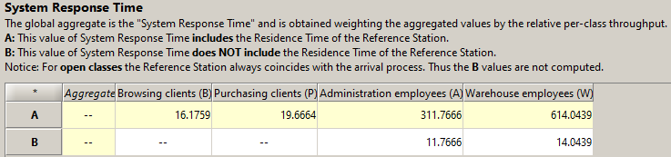

1. Throughput of the closed classes

1. Average number of jobs of the open classes

